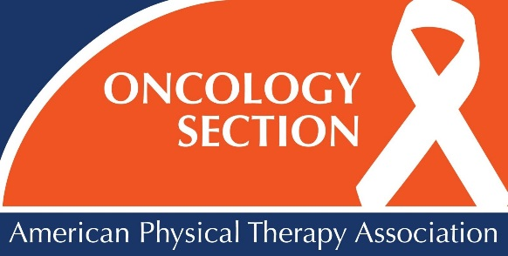

INTERESTED IN HOSTING AN ONCOLOGY SECTION REGIONAL COURSE?

RECEIVE 2 FREE REGISTRATIONS!

AVAILABLE COURSES

BREAST CANCER REHABILITATION (2 Day Course)
Speakers Available: Barbara Nicholson, PT, MSPT, CLT-LANA, Nancy Roberge, PT, DPT, MEd

END OF LIFE CARE
Speakers Available: Rich Briggs, PT, MA, Karen Mueller, PT, PhD Chris Wilson, PT, DPT, GCS

EVIDENCE IN ACTION: A COMPREHENSIVE MANAGEMENT OF
BALANCE IMPAIRMENTS AND FALLS (1 or 2 Day Course)
Speakers Available: Cindy Pfalzer, PT, PhD, FAPTA, Jena Colon, DPT, Earllaine Croarkin, PT, NCS

EXERCISE TRAININIG GUIDELINES FOR INDIVIDUALS WITH CANCER
Speaker Available: G Stephen Morris, PT, PhD, FACSM

HEAD AND NECK CANCER
Speakers Available: Melissa Eden, PT, DPT, OCS, Bryan Spinelli, PT, MS, OCS

WALK, RUN, JUMP AND THRIVE: PHYSICAL THERAPY FOR CHILDREN WITH CANCER
Speakers Available: Laura Gilchrist, PT, PhD, Lynn Tanner, PT

MANAGEMENT OF SURVIVORS WITH ADVANCED BREAST CANCER
Speakers Available: Linda Miller, PT, DPT, CLT, Barbara Nicholson, PT, DPT, CLT-LANA,
Nancy Roberge, PT, DPT, MEd

CONTACT THE ONCOLOGY SECTION FOR MORE INFORMATION

ONCOLOGY@APTA.ORG
800/765–7848, ext. 7107

