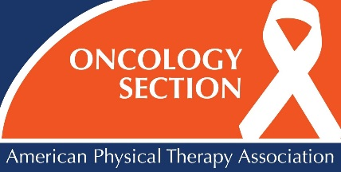

2019 ONCOLOGY SECTION REGIONAL COURSES – REGISTRATION FORM

Registrant Information:

Name: ____________________________________________________________________________________________________

Mailing Address: _____________________________________________________________________________________________

Phone #: ___________________________________________

Designation (PT/PTA/Student/Other): _____________________ APTA Member #: ____________________________

E-mail: ____________________________________________________________________________________________________

Choose a Course

Course Date Course Title Location

February 23, 2019 Exercise Training Guidelines for Individuals With Cancer Miami, FL

February 23, 2019 Head & Neck Cancer Grand Haven, MI

March 2, 2019 Exercise Training Guidelines for Individuals With Cancer Grand Haven, MI

March 8, 2019 What to Know about Oncology Rehabilitation for the Outpatient Clinician New Haven, CT

March 9, 2019 Exercise Training Guidelines for Individuals With Cancer New Haven, CT

March 10, 2019 A Comprehensive Management of Balance Impairments and Falls New Haven, CT

March 23, 2019 What to Know about Oncology Rehabilitation for the Outpatient Clinician Appleton, WI

July 13, 2019 Head & Neck Cancer Miami, FL

Course Fees: (Early-Bird Deadline is one month prior to the course. Advance Deadline is two weeks prior to the course.)

Early Bird Advance

Oncology Section Member $199 $229
APTA Member $245 $275
Nonmember $295 $325

SAVE ON YOUR REGISTRATION AND RECEIVE A FULL YEAR OF ONCOLOGY SECTION BENEFITS!

PRIOR TO REGISTERING, FOLLOW THE LINK BELOW AND ADD THE SECTION TO YOUR MEMBERSHIP.
THEN, PAY FOR YOUR REGISTRATION AT THE SECTION MEMBER RATE AND SAVE!

BECOME AN ONCOLOGY SECTION MEMBER!! GO TO – WWW.APTA.ORG/JOIN

PT - $45 PTA - $30 STUDENT - $20

Payment: Check made payable to the Oncology Section, APTA in the amount of $__________

Visa MasterCard American Express Discover

TO PAY BY CREDIT CARD: PLEASE CALL 800-765-7848, EXT. 7107 OR REGISTER ONLINE

Cancellation Policy: A refund, less $50 administration costs, will be issued for written requests postmarked 2 weeks prior to the course. The Oncology Section reserves the right to cancel the course with full registration refund only.

Mail Registration to: Oncology Section, APTA, 1055 N Fairfax Street, Suite 205, Alexandria, VA 22314
Questions? Call 800-765-7848, ext. 7107, or e-mail oncology@apta.org.

