Oncology Physical Therapy: A multi-cultural perspective.
Akshaya Savant
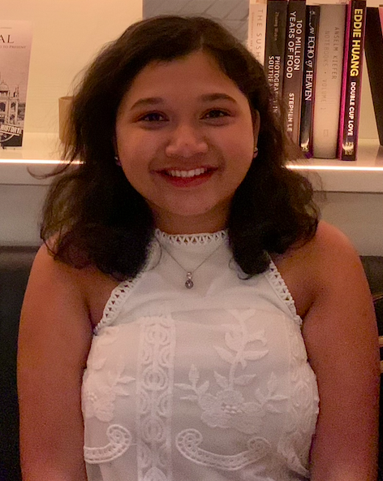

My introduction to the field of Oncology was through my father and grandfather, who were doctors at Tata Memorial Hospital (TMH), a premier Oncology specialty hospital and Research Center in Mumbai. They regularly spoke about cutting-edge care and surgical procedures on weekends. This built my interest in healthcare, and I pursued Physical Therapy. After getting my undergraduate degree in India, I decided to pursue a Master of Physical Therapy from Massachusetts General Hospital Institute of Health Professions (MGH IHP), Boston.

My initial interaction with Oncology patients started at Tata Memorial Hospital, Mumbai. I worked with an incredible team of physical therapists (physiotherapists in India) in a hospital setting as an observer. I witnessed volumetric measurements assessed in patients who had lymphedema, caliper measurements for patients with TMJ restrictions due to fibrosis of the jaw and surrounding tissue. Through my experiences, I observed that certain populations are prone to a specific cancer type due to their occupation and/or lifestyle. I was keen to use this information to create awareness about prevention and patterns at the workplace, specifically geared to fight the social pressure of chewing tobacco at a young age. I analyzed sputum color, viscosity, bloodstains, and patient’s lung sound after suctioning was performed. These small but important parameters help us assess the quality of chest physical therapy provided.

Long-term care is the goal for oncology-focused physical therapists and patients alike. To that end, I also participated in weekly post-operative care sessions that included incision assessment, drainage color examples, exercises, and lymphedema assessment. In this setting, I worked with patients in the pre-operative stage, post-operative care, and future care when the patients came for follow-ups with the doctor.

While honing my Oncology skills, I started working at Asian Cancer Institute (ACI) Cumballa Hill Hospital, Mumbai, to build a specialized department. I collaborated with a small team that was building the EMR system, developed treatment protocols for patients with different cancer types, and for treating critical cases requiring ICU rehabilitation. An important part of developing treatment protocols was to skillfully manage physical therapy (physiotherapy) around chemotherapy, radiation, and nutrition schedules. It is vital to know that, unlike other patients, oncology patients will be on a modified diet. This, combined with fatigue often discourages the patient from getting up from the bed. I reached out to their caregivers and found innovative ways to motivate the patient E.g.: Imagine you have to clean the ceiling fan to achieve shoulder movement and chest mobility. For lymphedema, I asked patients to make rotis (flatbread that requires kneading action).

Lung hygiene and chest physical therapy was a major goal for pre-operative patients. In one case, I got to know a patient’s favorite food was a laddoo - round Indian sweet that resembles a spirometer ball. I named each ball after it to enhance biofeedback. Some patients requiring chest physical therapy and lymphedema treatment will benefit more from split sessions addressing each condition daily. An important factor with goal setting is the need to adapt per the patient’s daily vitals and functionality. To improvise therapy protocols, it is important to understand the impact of surgical procedures on a patient’s body. We also programmed monthly meetings with the team of doctors and nurses, which aided patient outcomes. As a part of this incredible team, I got a chance to understand how the patient care team can collaborate seamlessly if everyone is in sync.

The PT Center at MGH IHP taught me clinical skills along with interpersonal dynamics while working with patients. I had the privilege to learn from the best Clinical Instructors and observed how space and equipment were efficiently used to ensure the smooth flow of patient care. I used my management skills from PT Center, and my knowledge about drug interactions, co-morbidities at ACI to treat Oncology patients.

As an observer, a student, and a physical therapist in an Oncology hospital, I learned that prevention is key, and it starts when you have knowledge about a certain disease and how it affects the human body. Remember, Cancer is a life-changing journey for a lot of families around the world. But you, as Oncology Physical Therapists have the tools to work with the patients and improving their quality of life one day at a time!

