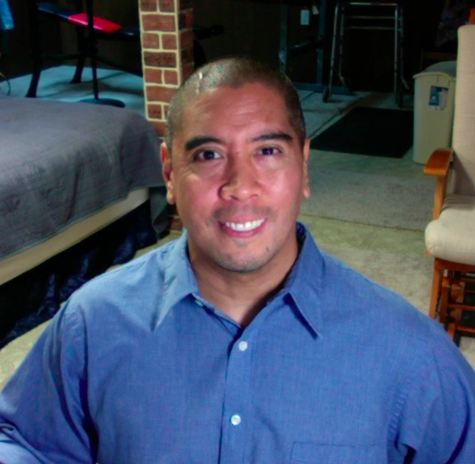
REVERSAL: When a PT Becomes an Oncology Patient with Physical Impairments

October 25, 2005 was the day everything changed. I graduated from the DPT program at the University of Michigan-Flint in December 2003. Shortly after graduation, I moved from Michigan to sunny San Diego, CA to start my physical therapy career. I started in Acute Care and then transitioned to Out-Patient Orthopedics. After watching the rest of my undergrad friends start their careers in the business or technology world, things were finally starting to happen for me! Things were great. I was in an exciting new city as a young professional. I loved my job and all the outdoor activities San Diego had to offer. Then in the summer of 2005, I started getting intermittent episodes of dizziness, headaches, and nausea. It got so bad that I went to an ENT because I thought I had an inner ear infection from surfing in contaminated water. I had an excuse for each symptom and would push through the symptoms to function everyday. I have always been the kind of guy who likes to push his physical limits. I learned how to swim just so I could go surfing and do triathlons. I completed 2 sprint triathlons and a half marathon in 2005, so I was physically fit and enjoying an active lifestyle on the West Coast! Then I received some shocking information.

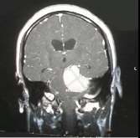
Nothing could have prepared me for the news I was about to receive. Brain cancer/tumors are pretty rare when compared to other types of cancer. On September 10th 2005, I found out I had a huge brain tumor, a meningioma the size of a golf ball, on the tentorial membrane at the base of my brain between my brain stem and my cerebellum.
At the time, you only heard about brain tumors when someone famous got one and died. The shock of diagnosis and location of the tumor freaked me out. The first thing I did was call my parents! That was the only time I let myself be scared. I had to talk to my brother separately once I figured out what was going on! The rest of my family and friends were informed once I “digested” the news. I promised myself I would not be scared so other people wouldn’t freak out. In the following months: I had brain surgery to have the tumor removed; radiation therapy to address the remains of the tumor; speech, occupational, and physical therapy for all the physical and cognitive impairments I was left with after the surgery; and then I had to come to terms with the fact that my short career working as a PT was most likely over! On October 25, 2005, I had an 8-hour craniotomy at the hospital where I used to work to remove the “non-malignant” brain tumor. In a strange twist, the people I used to work side by side with were now working with me as a patient after the surgery! I was left with severe balance, coordination, and cognitive impairments so I required all the rehab services: PT, OT, SLP, Nursing, SW, etc.

I felt more secure being in a familiar environment during a very unfamiliar and scary time! I actually enjoyed talking shop with my rehab team. It was strange at first, but eventually it felt almost “normal” to me. The biggest difference was that after a long day of “work”, I couldn’t go home and unwind. Now, I had to live with my impairments 24 hours a day, 7 days a week. I’m sure the whole situation confused my family because I had to explain EVERYTHING. I had to translate the rehabilitation jargon to my parents, while maintaining my composure! My family wanted to know what was going on all the time! It was humbling knowing what needed to happen to progress and failing to accomplish those goals. As a patient I really wanted to be prepared for what lay ahead. My physical therapy background helped immensely, but there were still a few things I wasn’t ready for. I had been exposed to a number of patients with different diagnoses, but I couldn’t find a book or other resource by a young single guy in the same boat as me. I was lying in my hospital bed and decided that when I got out of this, I would write a book… a “real” account of life as a patient for therapy students and younger patients addressing common situations and written in a style in which they could relate. I published my first book 2 years after my brain tumor diagnosis: Reversal, When a Therapist Becomes A Patient.
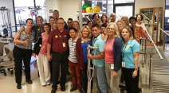
Shortly after publishing Reversal, I started meeting other survivors and decided to create a new nonprofit organization to unite different types of Oncology survivors and promote a proactive life after an intimidating oncology diagnosis called mAss Kickers Foundation (MKF). Through MKF, I was able to meet survivors and connect with oncology organizations from all over the world. More importantly, I was able to promote “post oncology treatment thrivership” to different patient groups, health care education programs, and professional organizations in different countries. I’ve been able to travel to: the Philippines, Japan, Singapore, Belgium, South Africa, Canada, and throughout the United States. In my spare time, I always enjoyed speaking to students about my experiences as a PT turned rehab patient and participating in neuro labs so students could practice their neuro evaluation/treatment skills at San Diego State, University of St. Augustine, Loma Linda University, and the University of Michigan-Flint. When the COVID-19 pandemic hit, MKF was dissolved because of the travel restrictions, but opened the door for me to get re-involved in the physical therapy profession. I discovered the new APTA ONCOLOGY, Balance and Falls SIG. I was immediately interested in the group as a former physical therapist with severe balance impairments from an Oncologic diagnosis. I felt like my experiences in the nonprofit world definitely gave me experience in both event planning and communications. I happily accepted the position of Membership and Communications Chair for the SIG. Way back in PT school, my classmate and I were the first students in our program to travel out of state for the APTA Student Conclave, and we were hooked! In the subsequent years, more students were traveling to national conferences. That trip created my interest in the different sections of the APTA. Dr. Jaqueline Drouin, one of my mentors from physical therapy school, was elected the president of the International Physiotherapists for HIV/AIDS, Oncology, and Palliative Care Empowerment. I managed to keep in touch with her after graduation from PT school because of her experience in Oncology Physical Therapy. I let her know that I was looking to somehow get re-involved in the profession. She asked me if I could assist with maintaining their new website. In PT school, I created a website for our class. Yes, I was the geek in my PT class! We used to post notes, pictures, videos, bios, and announcements on our website before Blackboard, Canvas, or Slack existed. I decided to help out with IPT-HOPE because of my interest in international health affairs, physical therapy, and website management.

I recently moved back to Michigan to be closer to family during the pandemic, but I’ve also found new ways to get involved in the physical therapy profession. I reconnected with many of the faculty at the University of Michigan-Flint who were involved in the APTA Oncology, Balance and Falls Special Interest Group. Dr. Cindy Pfalzer and Dr. Min Hui Huang were very active in the creation of the Balance and Falls SIG and invited me to attend their town hall meeting. I ended up accepting a position with them as the Membership and Communications Chair. Please check out our new project: the APTA ONCOLOGY FALLS SCREENING PROJECT we are starting for the 2021 PT DAY OF SERVICE. The screen will be based on the CDC’s STEADI program. We are still looking for assistance setting up local STEADI Fall Screening events at local Cancer Centers. This will be a great opportunity for exposure to the role of physical therapy in cancer care. Feel free to contact me at ericgalvez714@gmail.com for more information.

Eric Galvez YouTube video: https://youtu.be/qhYr1M5MpzQ

