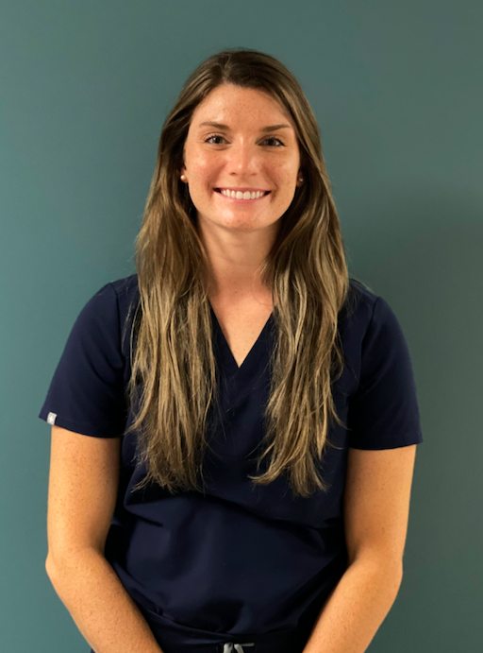
​​
Bridging the Care Continuum: Challenges in Bone Tumor Rehabilitation
Kolby Sharp, PT, DPT

My introduction to oncology started as most clinicians do, I had a close family member diagnosed with cancer, I was there as they navigated the multiple rounds of chemotherapy, radiation, and trial medications. This peaked my interest into the field, and I was curious about how I could contribute in a meaningful way to this population. As a new hire at The University of Texas MD Anderson Cancer Center, one of my first roles was managing the PT needs for post-operative orthopaedic and urology patients. I quickly fell in love with orthopaedic oncology and became interested in how these patients returned to their prior level of function or how they would navigate their new adaptive lifestyles. A new specialist PT opportunity presented itself in the department of orthopaedic oncology, I was quick to pursue it.
I am now a member of the orthopaedic oncology rehab team. My role is unique and challenging as I provide specialized PT services in both the acute and outpatient settings. Our niche population includes patients with major surgeries such as internal and external hemipelvectomies. Patients that undergo hemipelvectomy may have a large resection of their pelvis and, or a complete hindquarter amputation secondary to malignant bone tumors. I have the pleasure of evaluating and treating both pediatric and adult patients on their first day after surgery in the acute setting and often celebrate their graduation day from outpatient physical therapy. Each setting provides its own set of priorities and goals to accomplish. While acute care physical therapy focuses on the “now what do I do?” after surgery, the outpatient setting shifts focus to “what can I do now?”.
Going back and forth from outpatient to acute care can be a little challenging to adapt but keeping in mind the goals of the individual patient helps keep everything organized. Most oncology patients at baseline are typically dealing with side effects from chemotherapy; decreased exercise endurance, poor appetite, and sometimes muscle atrophy. Adding a major surgery such as an internal hemipelvectomy on top of that can wear a patient out! Acute care goals for this population are to return the patient to their prior level of function, or in other cases, getting them strong enough to discharge home safely. At this stage postoperatively patient goals include being able to get in and out of bed and ambulating without assistance. My main priority is patient safety with mobility as well as adhering to their surgical precautions, and sometimes those include the patient not being able to sit! I remember walking into my first ever internal hemipelvectomy patient room and thinking to myself “how will I ever get this man to walk normally again, he only has half his pelvis?”. Fast forward several sessions, hard work from the patient, and a skilled mentor later the patient was ambulating down the hallway with just a rolling walker and standby assistance!
In transition to the outpatient setting, the goals change compared to the acute care setting and are catered to the patient’s functional needs, while also maintaining surgical precautions. Patients are typically more independent and are capable of performing the majority of functional mobility without close guarding or assistance, which took me a solid 30 minutes into my first outpatient session as a new graduate to adjust to! Patient’s typically experience fatigue and occasionally nausea, side effects of receiving chemotherapy. Therefore, as a PT adapting to how the patient is feeling the day of the PT session and adjusting the session to what they are able to do comfortably will allow the patient to feel accomplished.
Watching our patients overtime get stronger and achieve their goals through hard work and determination are what keep me motivated and make me proud to be a physical therapist. My best parting advice is this, practice patience with your patients, as odd as that sounds. In the field of oncology there are great days and there are okay days and then there are the very bad days. Realize that your presence has an impact on each patient’s day and when developing yourself clinically think what type of impact you want to leave. I am very grateful to have found my passion and hope you all enjoy the field of oncology as much as I do!

